Quick note: We are always told to comment our code so that people reading it can tell what is going on. This code contains a single comment that tells the reader practically nothing. Just something interesting that I noticed.

First run in GDB:

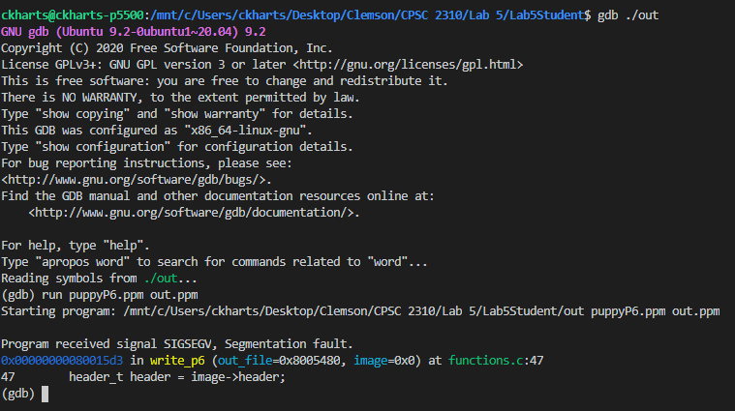

Second run, trying to figure out what’s going on here…

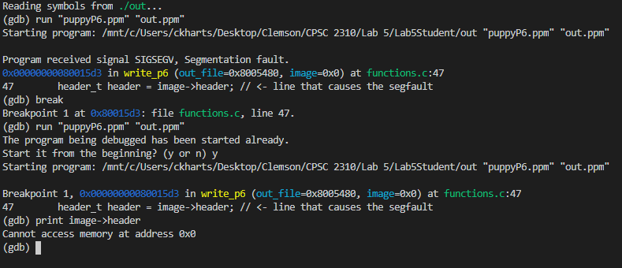

This is a fun one.

  
So GDB can’t access the memory…? There’s trickery afoot.

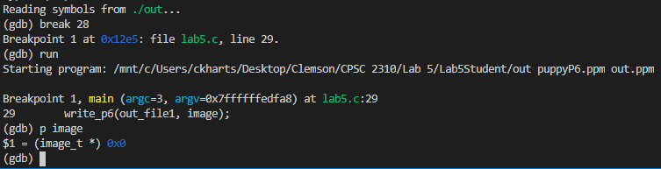  
Looks like image is being initialized to NULL somewhere.

After checking the initialization, I realized that the function meant to give it a value wasn’t being called correctly. After fixing that, the program works.